Directions for completing the 2 hour inservice for Pupil Transpirtation:
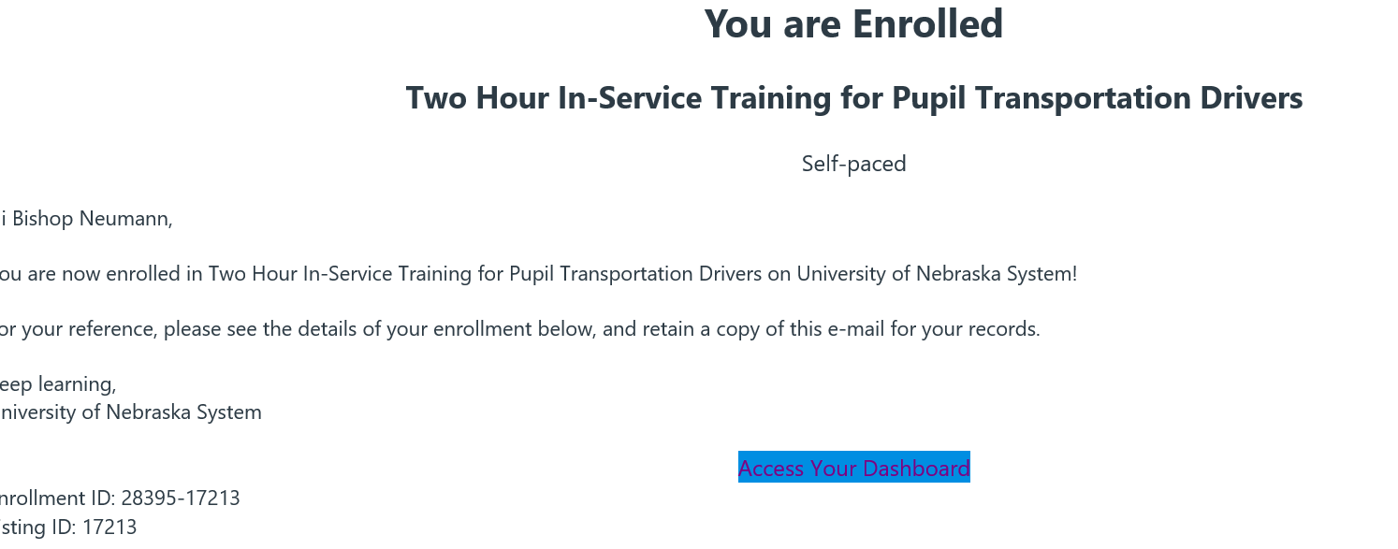
- Click on access your dashboard

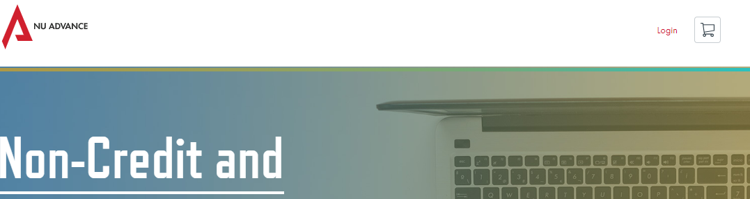
- Click on Login
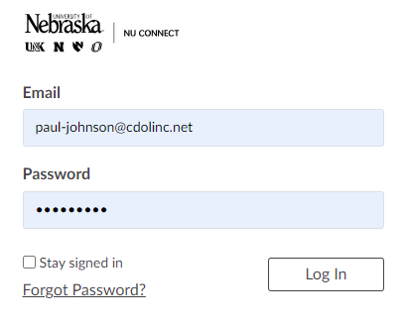
- Use paul-johnson@cdolinc.net for email
- Use bnbus2023 for password
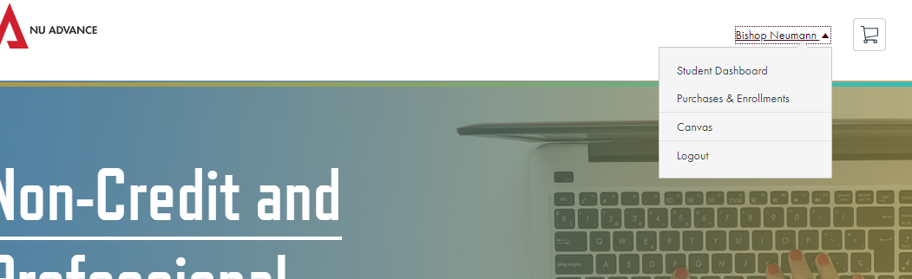
- Click on Bishop Neumann then click Canvas

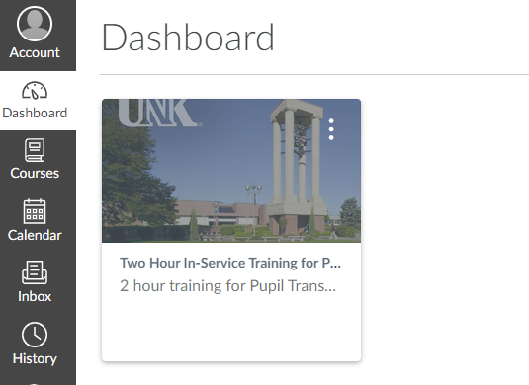
- Click on the two hour in-service training for pupil transportation
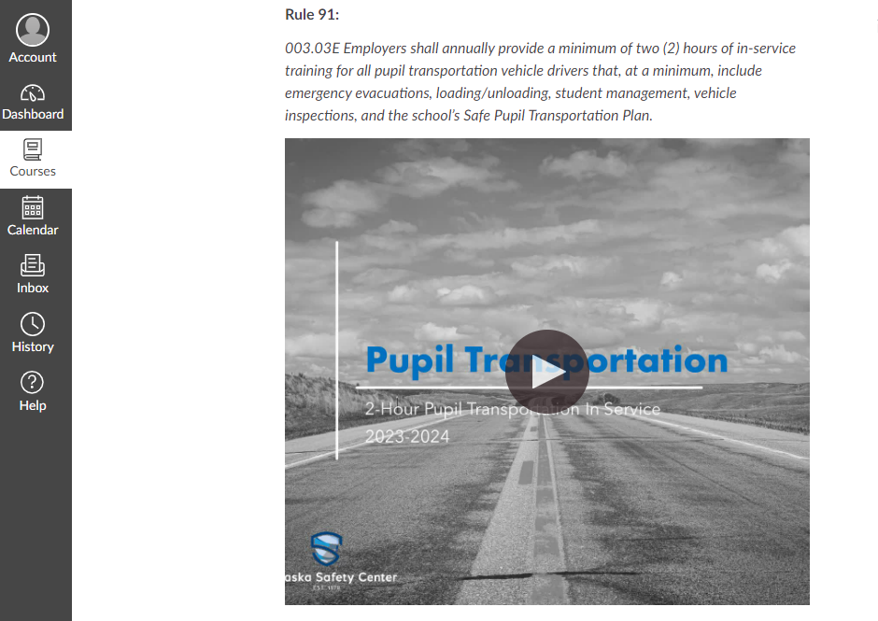
- Click on the video and watch. It is 133 minutes

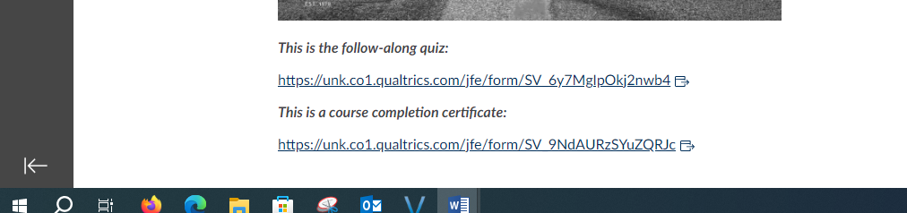
- After Completing video, click on the course completion certificate
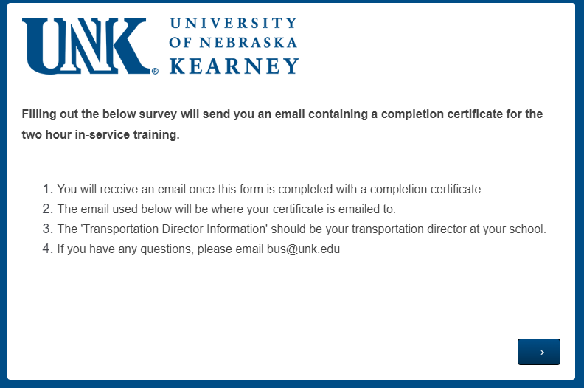
- Click the arrow after reading
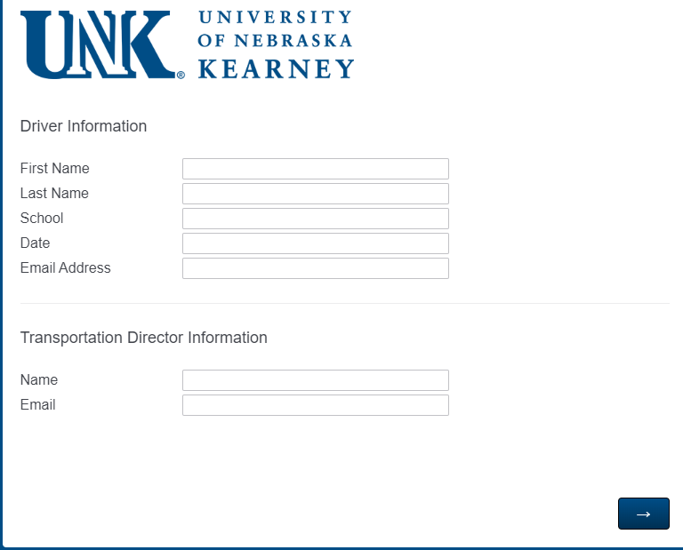
- Type your information in the driver information
- Type Paul Johnson and Paul-Johnson@cdolinc.net for the transportation director
- Then hit the arrow
- This should send you and Paul a certificate of completion

